How could I recognise a student who has an executive functioning difficulty?

SUMMARY:
Cognitive strategies are tactics or brain generated mental techniques which students use to
- Identify important, unfamiliar or complex information
- Understand and retain information
- Retrieve information from memory stores
- Manipulate and apply information
- Plan and modify behaviour, using information
Students need to use these strategies in the ‘here and now’, choosing the best strategy to fit a particular situation. Some students do not use strategies efficiently to enable them to be ‘ready for learning’

READ ON TO LEARN MORE:

Reading Molly’s story, we can identify some specific and observable breakdown points in her executive functioning. Each of these breakdown points can be attached to a targeted teaching strategy.

Molly:
When activities are straightforward I am OK - I know what to do but when activities are a bit complicated, like the art project we got at the beginning of last term, I can spend ages going round and round in circles. The whole process is so frustrating because I was so excited. I really love drawing and painting and designing and creating. I’m good at it. I want to be an art teacher. This project – I spent ages thinking about different ideas but I couldn’t settle on one. I started on one idea then stopped, then started on another idea then stopped. I honestly don’t know what the obstacle was. For some reason I just couldn’t choose which idea to go with. When I did choose something I couldn’t stick with it - stay focussed on that one idea. Before I realised, I had run out of time. I knew I was meant to do the first thing first, then the second thing next, then the next thing – like a number sequence – but I just couldn’t plan it out. At the last minute I created an art work which was not amazing. I didn’t get good marks. I knew my teacher was disappointed in me and I was disappointed too. I am starting to worry about failing and stuff like that.

Molly’s teacher:
Molly is a treasure! Caring, kind – and a bright spark! But all too often I don’t get to see her potential. Example: This morning in literacy, Molly mustn’t have been listening to my instructions because when all the other students started on their half yearly test Molly didn’t start right away. I repeated the instructions again just for her. It wasn’t till I was marking the students’ work that I realised she hadn’t zeroed in on the specific task goal. She hadn’t answered the question! Her writing was off on a tangent. I’m confident that if she had looked for and located the key words in the question, and mapped out a response that matched the question she would have got high marks. Instead………… It’s confounding to watch because her long term memory is spot on but her working memory for the ‘here and now’ is a very real problem. For a girl who is definitely clever, why does she stumble with complex sequenced information? Another thing I have noticed. Molly is very popular but she seems to need her friends to organise her at recess and lunch – in these unstructured times Molly is at a bit of a loose end. The other girls tend to do the organising of their free time.

Molly’s parents:
Molly is clever and fun to be around. A very capable student with a strong creative bent. But my goodness – she struggles with self-organisation, particularly with unstructured tasks or time: weekends and holidays can be tough for her and for us because she needs so much adult direction. She is constantly in chaos and seems to get overloaded when too much is happening around her. Going to school and leaving her lunch on the bench in the kitchen. Last holiday at the beach: we were going for 2 weeks, she packed 10 books to read – enough to read for 2 months but left her swimming costume in her beach bag on the bed. Homework is always being done at the 11th hour. It’s affecting our relationship because we shouldn’t have to be organising her now. She doesn’t seem to notice that she is out of step with what needs to be done and when it needs to be done. And she doesn’t seem to learn from experience either! We are constantly nagging her to get her act together. Sometimes I laugh because she genuinely seems surprised at what is happening next. We have tried to help her monitor what she is doing with timetables on the fridge door and charts with tick boxes. But she is restless and isn’t able to persist with any plan we implement! Both her planning strategies and her coping strategies are so restricted!

Molly’s occupational therapist:
I look forward to my sessions with Molly, but from information gathered in questionnaires from her teacher and parents as well as my own observations, Molly presents as having difficulty with critical aspects of executive functioning.

During a WRITING task
Executive functioning  required by the task | Observed difficulty  Molly
Initiating | doesn’t know how to start writing the essay
Organising | has no idea how to map out the essay
Prioritising | writes too much about elements which have minor importance
Sequencing | presents facts in illogical order

During a TEST task
Executive functioning  required by the task | Observed difficulty  Molly
Attending | is easily distracted, can’t stay focussed on task
Choosing strategies | doesn’t develop a plan of attack by viewing test instructions and questions before starting
Recalling facts | has trouble remembering previously learned information and mentally manipulating related facts to answer test questions
Timing | spends too much time on some questions, rushes through others

During a LEISURE activity with peers
Executive functioning  required by the activity | Observed difficulty  Molly
Self-regulating | has trouble waiting her turn, being cooperative
Evaluating | lashes out verbally when frustrated – before trying to understand the problem and figure out how to manage the conflict

Students often come to our attention when the increasing expectations of school exceed the student’s restricted self-management strategies. One ultimate goal for all students is to self-direct and self-regulate for skill performance in an organised way. Self-regulation means being able to control impulses to stop doing something and to start doing something different, to think ahead to possible consequences of actions,
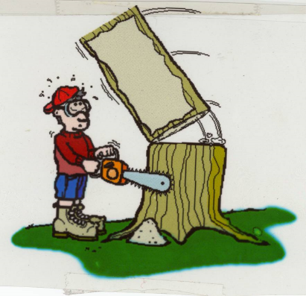
to consider alternative actions. These crucial capacities underpin mindful, intentional and purposeful goal directed behaviours within an expected time frame for both academic learning and for social emotional learning. Kindergarten teachers rank self-regulation as the most important competency for school readiness! Researchers have observed a link between self-regulation at an early age and an individual’s performance throughout primary school, high school and later life.

Often, a student’s behaviour is inappropriately attributed to disobedience and defiance, or deliberate attempts to be naughty or laziness or anxiety or teaching or parenting. The basic difficulties relate mostly to the way a student processes complex sequences of information. Therefore a student can perform to a very high level on some tasks and yet be well below average on other tasks. In times of stress and anxiety, performance, coping and behaviour can significantly deteriorate.

Observation of a student’s ability to perform complex self-managed tasks in everyday school life is an ideal way to assess students with executive functioning difficulties. Student’s performance on single tests consisting of artificial tasks and administered in the vacuum of a 1:1 situation outside the classroom cannot reflect real world performance. In natural contexts occupational therapists can use an occupational therapy assessment called the Perceive Recall Plan and Perform System of Task Analysis with teachers and parents. This helps us describe a student’s functional performance, and the cognitive strategies the student is applying – or not – to their engagement in everyday tasks. Tasks such as getting ready for school, doing a group class project, dealing with conflict in the playground, organising personal belongings or completing homework within a reasonable time

SUMMARY:
At a TASK level students can demonstrate THINKING ERRORS which result in the
following four consequences. The task being performed
- Too slowly
- With missing steps
- With no accuracy
- In the wrong sequence

READ ON TO LEARN MORE:

THINKING ERROR ONE: resulting in a task being performed TOO SLOWLY

Getting Ready for School
Parent expectation: Molly’s mum expects her to be ready to hop in the car with her siblings at 8.10 so she can drop the children at school on her way to work.

Using task analysis, Molly needs to
- Get out of bed when mum knocks on her door and turns the light on
- Feed her fish
- Eat her own breakfast which is laid out on the table
- Have a shower
- Get dressed
- Brush her teeth
- Comb her hair
- Pack her recess and lunch which is on the kitchen bench
- Make her bed
- Play her iPad if all her subtasks are completed to expectation
- Leave on time with her school bag in hand
Observation indicates
Molly takes ages to eat her breakfast – she physically chews slowly, she gets distracted by her siblings, she stops eating to listen to her mum’s phone conversation, she doesn’t stay on task: getting up from the table to play with the cat. Performing this routine too slowly impacts on her ability to successfully participate in being ready for school on time.

THINKING ERROR TWO: resulting in a task being performed WITH MISSING STEPS

Tidying Bedroom
Parent expectation: Molly is expected to keep her room relatively tidy – tidy enough that mum is not tripping over things in the dark when she tucks Molly into bed at night and tidy enough that Molly can find what she needs.

Using task analysis, Molly needs to
- Put all the books on the shelf
- Put all the rubbish in the bin
- Put homework on the desk
- Put pencils, rubbers etc. in the pencil case
- Put school clothes on the chair
- Put dirty clothes in the basket

Observation indicates
Molly skips some of the subtasks. She misses putting school clothes on the chair, misses putting dirty clothes in the basket. Next morning she realises too late she hasn’t got a clean uniform and it is her class’ turn to lead the school assembly.

THINKING ERROR THREE: resulting in a task being performed with NO ACCURACY

Doing Neat Bookwork
Teacher expectation: Molly and her classmates are expected to present their work neatly in their writing books.
Molly needs to
- Open her writing book
- Find the last page of writing
- Turn to the next page
- Rule margin on side of the page
- Write the short date at the top left of the page
Observation indicates
Molly has begun her work on random pages. She doesn’t start on the correct page. Moreover, she doesn’t notice the error.

THINKING ERROR FOUR: resulting in a task being performed in the WRONG SEQUENCE

Doing a Maths Worksheet
Teacher expectation: Molly is expected to carry out an estimation mathematical operation with steps in the correct order.

Observation indicates
Molly does steps in the wrong order. She adds items before estimating

All of these mistakes are task errors. The outcome is that some students who are academically able may not demonstrate their abilities because of their strategic approach.

SUMMARY:
So WHY so do some students demonstrate difficulty with these everyday tasks?

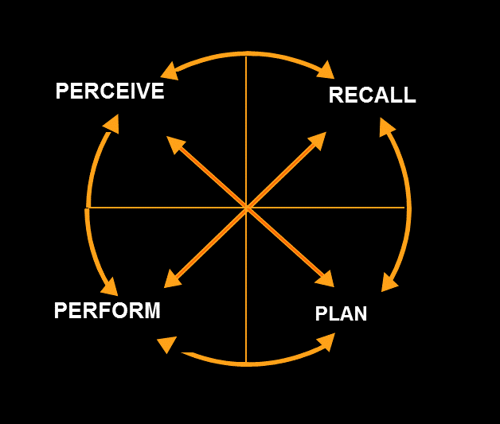
Using the PRPP System of Task Analysis, occupational therapists can explore with teachers and parents four main dynamic and interactive information processing domains:
- PERCEIVE
- RECALL
- PLAN
- PERFORM

READ ON TO LEARN MORE:

Domain 1: PERCEIVE

SUMMARY:
Students need to gather and process sensory information, be in an alert state of readiness
for learning.

Teachers, parents and occupational therapists need to work together to prepare the
student for processing information, to be ‘body ready’ for ‘brain engagement’ in learning
through
- Environmental accommodations e.g. being provided structure, routine, order
- Calming spaces e.g. being in a quiet space in the corner of a room
- Exercise / proprioceptive ‘heavy muscle work’ activities e.g. carrying books in a tub
- Cognitive strategies e.g. learning how to ignore distractions

READ ON TO LEARN MORE:

This involves the child’s ability to
- regulate alertness
- sense what is going on within self and around self
- apply inhibitory control: to a response which is relatively automatic
- focus on relevant information for a sustained period of time, shift attention when needed, resist distraction from irrelevant intruding stimuli

Focusing our senses on what is happening in our environment allows us to make meaning of information and to remember things more efficiently. This is the domain which relies heavily on efficient sensory processing.

Domain 2: RECALL

SUMMARY:
Students need to recognise, store and retrieve information. They need to know when,
where, what and how to ‘do’.

Teachers, parents and occupational therapists need to work together to help the student
build a functional filing system for recognising, storing and retrieving information.

READ ON TO LEARN MORE:

Whenever we use the word ‘know’: we are tapping into the fact that the student remembers what he/she has experienced or learnt – stored information. Students often have difficulty remembering because they did not attend to the task and the information slips away. It was not stored. Or, information was stored but not organised effectively so it is difficult to ‘find’. The bridge between perceiving and recalling is too fragile. Language processing is very important for recall because language gives information a label so the student can categorise, file and organise the information.

One aspect of recall is working memory: being able to maintain multiple pieces of verbal and visual information in mind, and manipulate that information to guide immediate behaviour – without the use of external cues to inform you. An example:

Teacher expectation:
Write your name on the top of the page, colour the pictures that are the same in each box. Then put your worksheets on the blue table and come sit on the floor.

Student behaviour:
Writes his name, colours all the pictures, sees the other children sitting on the floor – goes to the floor, leaving his worksheet on desk

Working memory can only hold a small amount of information for a short period of time. Maintaining and manipulating this information requires focussed attention and mental persistence. Complicating efficient recall is the lack of an internal
clock against which the passing of time is measured. Some students struggle to conceptualise the length of time that a given activity may require, often leaving far too little time. So quality and quantity of work, to teacher expectations within set time frames, is problematic!

Domain 3: PLAN

SUMMARY:
Students need to manipulate, use and evaluate information.

Teachers, parents and occupational therapists need to work together to enable the
student to select and apply strategies in new learning experiences so that the student can
organise how to do the task or social interaction.

READ ON TO LEARN MORE:

Planning requires
- mental flexibility or cognitive agility
- knowing and keeping a goal in mind
- using effective strategies
- sequencing
- evaluating things from different perspectives
- solving problems in new ways
- tolerating ambiguity and uncertainty
- learning from mistakes or thinking errors
- prioritising

Difficulty with prioritising, combined with memory difficulties, often results in work being
handed in late or not at all. Research indicates that for children with a learning difficulty the
ability to plan is the most difficult challenge of these 4 domains. By 9 years of age typical
students have the capacity to problem solve by discarding inefficient solutions that are not
working and searching systematically for better alternatives. They have the ability to identify
a problem, generate plans, figure out which plans are helpful or not helpful – but more
importantly – why or why not, make a decision and act on that decision.

Domain 4: PERFORM

SUMMARY:
Students need to monitor their performance within tasks and social interactions.

Teachers, parents and occupational therapists need to work together to refine a student’s
skill to ‘do’: perform / behave within classroom and playground contexts.

READ ON TO LEARN MORE:

This is the ability to
- initiate: get started
- adapt to change
- take risks willingly
- pace oneself: not too fast but not too slow
- monitor actions and adjust accordingly

Students with information processing difficulties struggle to connect separate items of information in a meaningful way in order to generalise their learning from one experience to another, from one task to another, from one context to another. For them, information often exists as a stand-alone with no cross referencing occurring in the learning process. Stein and Chowdhury in their book ‘The Disorganised Child’ conceptualise this visually as a ship’s wheel / wagon wheel

in which all the spokes radiate out from a central hub without being connected to one another. In comparison organised children have thinking processes which are conceptualised visually as a spider’s web

in which each strand of information is inherently linked to the whole scheme. Given this difficulty in connecting separate pieces of information effectively, students with executive functioning difficulties find it difficult to think flexibly, to make correlations, to apply principles of cause and effect, and to generalise their learning.

These 4 domains: Perceive, Recall, Plan and Perform are part of one big and continuous feedback loop which operates with rapidly shifting interactive dynamics to do a wide variety of everyday tasks.

These skills require self-regulation by the student rather than micro-management by a teacher or parent. The good news is that the skills within these domains can be learnt! Neural connections can be strengthened enabling flow!

But only if we embed and practise targeted strategies in contextual school tasks with learning outcomes or embed and practise in contextual home routines with participation outcomes. Effective communication between school and home will only increase potential outcomes!

