What sensory processing strategies could I adopt to enhance

student engagement for learning?

SUMMARY:
Research informs us that the following three evidence based approaches make a difference
- Vigorous exercise / ‘heavy muscle work’ activities
- Calming spaces
- Environmental modifications

READ ON TO LEARN MORE:

- Exercise / proprioceptive ‘heavy muscle work’ activities

Vigorous exercise and proprioceptive or ‘heavy muscle work’ activity has an impact on the cerebellum in the brain, resulting in increased calmness, allowing the student’s ‘engine’ to ‘be in the just right zone – being not too slow and not too fast’.

Heavy muscle work or proprioception is the great organiser of all sensations.

Proprioceptive activities involve pushing, pulling, lifting, carrying, dragging.
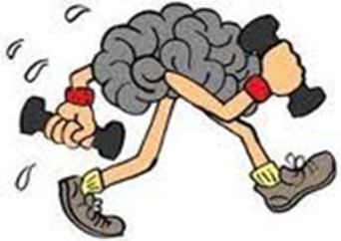

Proprioception is the ‘safe sense’ and helps a student’s ‘engine to run just right’.
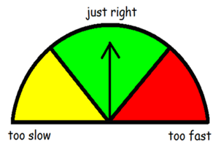

Proprioceptive activities help teachers and parents to bring students whose level of alertness is too low ‘up’ or bring students whose level of alertness is too high ‘down’.

What does research state?
Research with students who have Autism Spectrum Disorder (ASD) demonstrates that proprioceptive activity
- decreases self-stimulatory behaviours, aggression and off- task behaviour
- increases on-task behaviour and academic responding

Research with students who have Attention Deficit Hyperactivity Disorder (ADHD) demonstrates that proprioceptive activity
- increases attentiveness and calmness

Research with students who are typically developing demonstrates that proprioceptive activity
- increases attention and academic performance

How often?
Research indicates students with sensory processing difficulties benefit from vigorous exercise or proprioceptive ‘heavy muscle work’ activities every 40 – 90 minutes.

Occupational therapists work with teachers and parents and individual students to
- personalise the ‘Alert Program’
- design sensory programmes which include proprioceptive ‘heavy muscle work’ activities

Tier 1 Strategies
- Deep breathing
- Movement breaks after each learning activity
- ‘Hand Muscle Gym’ before a handwriting lesson
- Chair push ups
- Eating crunchy or chewy foods during ‘sip and crunch’, recess and lunch
- Drinking through a curly ‘hard suck’ straw – water container on desk

Tier 2 Strategies
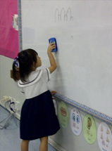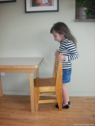

- Carry books or equipment in tote trays, sports tub
- Clean the board
- Set up the classroom, lifting chairs onto / off the desk
- Wipe down the desks
- Hand out books
- Push open a heavy door
- Theraband stretched between front legs of chair (push with foot or leg)
- Self-tight squeezes
- Floor push ups
- Sit ups
- Sharpen pencils
- Catch and throw heavy balls
- Climb equipment (including monkey bars) in the playground
- Sack jump in PDHPE
- Use focus tools e.g. squeezy ball, koosh ball, theraband, blutak, punki wrist band, play dough, kinetic sand, slinky key ring, wooden massager, hair brush, water ball
- Allow student to high kneel, side sit, squat

Tier 3 Strategies
- Any vigorous physical activity
- Wall pushes
- Commando crawling
- Allow student to wrap self in blanket and pull blanket tightly round self

Activities which might be practical in home / preschool contexts include
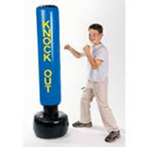
- Gardening activities: pushing a wheelbarrow, digging with a spade, carrying a full watering can, hosing, raking, sweeping
- Building activities: Hammering
- Cooking / clay activities: pouring, stirring, squirting, squeezing (oranges), pounding, kneading, rolling
- Home chore activities: sweeping, carrying shopping in from car, pushing washing trolley to clothes line
- Play activities at the park: climbing, crawling, hanging, rolling
- Gym type activities: tug of war using a towel, sit ups, push ups, somersaults, arm wrestling
- Eating activities:
- chewing e.g. meat, apple, carrot, celery, muesli bar, fruit bar, fruit leather, beef jerky, popcorn, gum
- crunching e.g. e.g. apple, carrot, celery
- sucking through a ‘curly hard suck straw’ e.g. milkshake, fruit smoothie
- Ball activities: catching, hitting, throwing especially with heavy ball or bat
- Fine motor activities (colouring, puzzle) on floor with arms propping body
- Animal walks: crab walks, frog jumps, bear walks, wheelbarrow walks
- Blowing bubbles (facilitating deep breathing)
- Jump rope activities
- Crushing cans for recycling
- Using punching bag
Activities which might be enjoyable in sport or leisure activities include
- Rock climbing
- Boxing
- Dancing
- Gymnastics
- Martial arts

A sensory programme designed by an occupational therapist in partnership with the teacher and parents of one young student might look like the following:

Before school | Wake up: bear hug from mum or dad  Be carried to lounge room tightly wrapped in blanket to get dressed  Wheelbarrow walk down hall for breakfast  Eat crunchy toast, chewy cereal, crunchy apple  Drink though curly straw  Use electric toothbrush  Play on climbing equipment at school before bell rings
At recess | Wipe white board  Eat crunchy food: celery, carrot with dip  Eat chewy food: muesli bar, fruit bar  Drink through curly straw  Play obstacle course climbing over, under, through  Do chair push ups
After school | Carry own bag to car  Have crunchy / chewy snack  Play on trampoline  Hammer blocks  Have chewy dinner (meat and vegetables)
Before bed | Have firm rub down with wash cloth in bath  Have tight wrap up and squeeze in drying towel  Sleep with fitted tight sheet and blanket

- Calming spaces

- Provide quiet space in corner of room (tent, bean bag)
- Provide ‘no stimuli’ space for student to ‘block out’
- Provide a ‘light reduction’ environment by dimming lights, allowing student to wear sunglasses
- Provide a study barrier
- Provide calming music

- Environmental modifications

General:
Tier 1 Strategies
- Accompany verbal instructions with visual prompts
- Draw attention to key information (highlighting key words verbally and visually)
- Break down instructions into small steps and allow students time to process
- Provide order, structure and routine

Tier 2 Strategies
- Sit students with sensory processing difficulties at the front of the class
- Sit students with sensory processing difficulties away from windows and doors
- Allow additional ‘body space’ when students sitting as a group on the floor
- Provide student with language to communicate level of sensory arousal and level of sensory need. The Alert Program provides an approach to use in partnership with the student’s occupational therapist
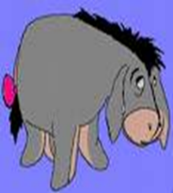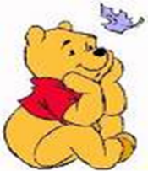
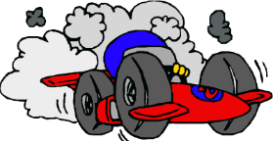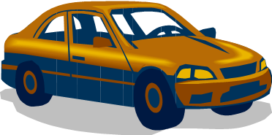
High level of arousal = hyperactive, distractible behaviour = Tigger / racing car
Low level of arousal= lethargic, flat behaviour = Eeyore / cement truck
Just right level of arousal = Pooh Bear / family car
Specific to students with auditory processing difficulties:

Tier 1 Strategies
- Be aware of level of classroom or playground noise. Use noise-meter in classroom
- Use ‘Arc of Arms’ rule i.e. be aware that students who are within range of your outstretched arms will be the more attentive recipients in the classroom
- Provide written instruction to supplement verbal instruction
- Provide class with 5 minute whisper break
- Have muffled area with cushions, headphones
- Play soft music for calming or for transitions
- Monitor tone of voice
- Have a balance of noisy and quiet activities during the day
- Have auditory prompts for cueing in the next activity e.g. gentle music but avoid sudden / loud noise such as bells
- Provide warning before any sudden / loud noise e.g. siren for evacuation practice
- Use ‘sensory’ language
- Listen with your ears
- Are you listening with your ears to what is happening around you?
- Listen, can you hear the same / difference?
- Listen, can you hear what it is like when we are quiet?
- Think with your ears
- Get your body ready to stop and listen

Tier 2 Strategies
- Prior to instruction, cue student to gain attention
- After class instruction, ask student what needs to be done
- Allow extra time for student to respond
- Allow student to wear ear plugs / unplugged earphones
- Allow student to use iPod with calming music
- Allow student to control sound e.g. click ‘play’ on machine for music
- Provide quiet space in corner of classroom
- Encourage student to use finger or card under a reading line
- Provide card to cover other areas of the page

Tier 3 Strategies
- Listen to relaxation tape

Specific to students with visual processing difficulties

Tier 1 Strategies
- Turn off lights during quiet breaks
- Have visual schedule for the day
- Have an area where there are no stimuli (e.g. posters) for students to ‘block out’

Tier 2 Strategies
- Reduce / eliminate visual clutter
- on desk
- near desk
- between desk and board
- on board
- on worksheet
- Establish eye contact with student before instruction
- Put border around critical relevant information on board or worksheet to isolate from less critical information
- Teach ‘puzzle’ concept
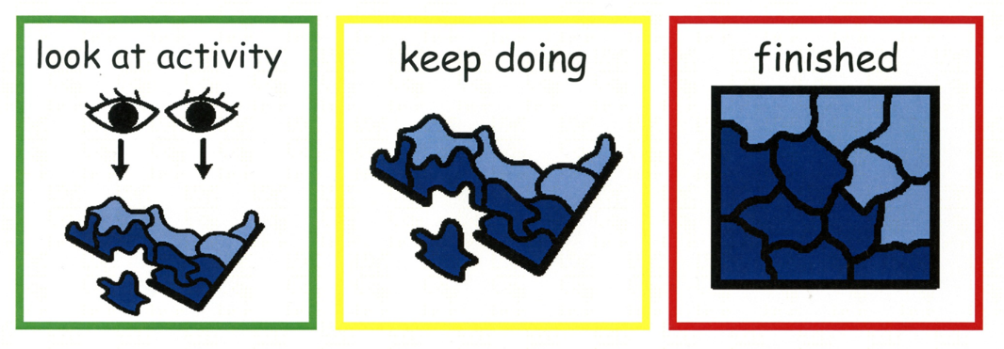
- Use ‘sensory’ language
- Look with your eyes
- Look, find one like this
- Look, they are the same
- Are you looking with your eyes at what is happening around you?
- Think with your eyes
Specific to students with oral (taste, texture, temperature) processing difficulties

Tier 2 Strategies
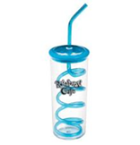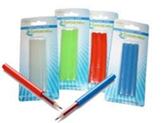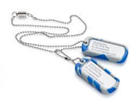

- Student be provided with appropriate objects to put in mouth e.g. chewing gum, minties
- Student has water container on desk with straw for sucking
- Student chew on pencil chews
- Student chew on chew tags
- At food breaks, student eat crunchy foods e.g. apple, carrot, celery
- At food breaks, student eat chewy foods e.g. muesli bar, fruit bar, fruit leather, beef jerky, popcorn, gum
- In music lesson, student play instrument that uses mouth e.g. harmonica, recorder, tin whistle

Specific to student with touch processing difficulties

Tier 1 Strategies
- Allow student to sit at edge of group: not in middle of group
- Allow student to stand at beginning or end of line: not in middle of line

Tier 2 Strategies
- Avoid touching student from behind
- Avoid unpredictable touch
- Avoid light touch: replace with predictable, deep, firm sustained touch
- Allow student to direct tactile input: hold another student’s hand, rather than be held

Specific to students experiencing difficulties with
- proprioceptive (body position)
- vestibular (movement and balance)

Tier 1 Strategies
- Provide maximum seating room at desk and on mat to avoid students bumping each other
- Allow sufficient space between furniture so students don’t bump into desks
- Use ‘sensory’ language
- Feel what it is like to be still

Tier 2 Strategies
- Provide a variety of objects for students to sit on instead of a chair e.g. gym ball, hot water bottle filled with cold water, bean bag, ‘move n sit’ cushion
- Provide something for student to lean on when sitting on the floor
- Allow student to sit in various positions e.g. lying flat on floor propped on elbows, standing at table
- Define area for student to sit e.g. masking tape, carpet square
- Allow student to get up and move during desk activity as long as student
- does not interrupt others
- uses the movement to self-regulate and then complete work

