How could I recognise a sensory processing difficulty in my student?

SUMMARY:
A student may have a sensory processing difficulty if his / her engagement for learning is negatively impacted by inefficient processing within the following systems
- auditory - hearing
- visual - vision
- tactile - touch
- oral / gustatory – taste, smell and sensation in and around the mouth
- proprioceptive - body position
- vestibular – balance and movement
- temperature
- pain

READ ON TO LEARN MORE:
Inefficient AUDITORY processing

Trigger stimulus examples |  | What might I  sense? | What might I do?
Hear object  falling  Classroom  chatter  Air  conditioner | 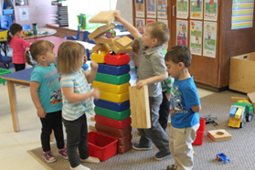I | Sound of  crashing  thunder | Over-react to sound: put my  hands over my ears  Not react to sound  Not be able to distinguish  meaningful sounds from  unimportant sounds  Be distracted by irrelevant sound  Need instructions repeated  Give inappropriate response  Respond slowly

Inefficient VISUAL processing

Trigger stimulus examples |  | What might I  sense? | What might I do?
Bright  light  Cluttered  board  Cluttered  worksheet  Busy  playground |  | Unbearable  glare | Over-react to visual stimulus /  information which other students are not distracted by: hide, cover eyes,  squint  Not notice visual information which  should be noticed  Look away from task to notice all  actions in room  Have difficulty finding objects in  competing backgrounds (e.g. pencil  in pencil case, maths book in tote  tray)  Become lost easily  Have difficulty copying from a  cluttered board  Have difficulty doing a cluttered  worksheet  Stare, look too intensely  Be cautious at steps, kerbs

Inefficient TOUCH processing

Trigger stimulus examples |  | What might I  sense? | What might I do?
Feel shirt  tag |  | Irritating itch | Refuse to wear clothing item  Over-react to being touched  Be unaware of being touched  Bump into others  Push others  Excessively touch others / objects  Bite self

Inefficient TASTE processing

Trigger stimulus examples |  | What might I  sense? | What might I do?
Be offered  foods  with  different:  taste  texture  temperature | 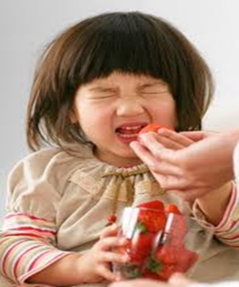 | Offensive  taste  texture  temperature | Gag  Be a ‘picky’ eater  Have messy eating habits  Suck, chew, lick inedible objects e.g.  pencil, shirt collar  Be unaware of food around mouth  Dribble

Inefficient SMELL processing

Trigger stimulus |  | What do I sense? | What might I do?
Smell teacher’s  perfume |  | Offensive smell | Run away

Inefficient PROPRIOCEPTIVE processing

Trigger stimulus |  | What do I sense? | What might I do?
Line up outside  classroom  Play games  Climb steps | 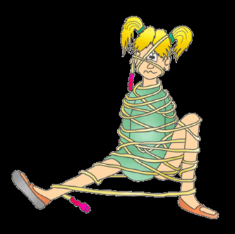 | Inaccurately sense  position of my body  IN SPACE, enabling coordinated  movement | Be clumsy  Bump into others  Use unexpected  force

Inefficient VESTIBULAR processing

Trigger stimulus |  | What do I sense? | What might I do?
Run  Sit at desk |  | Inaccurately sense  position of my body  with respect to  GRAVITY, enabling  balance and upright  posture. | Feel dizzy  Fall over  Wriggle constantly  Fall off my chair

Inefficient TEMPERATURE processing

Trigger stimulus |  | What do I sense? | What might I do?
Go from classroom  to playground in  winter | 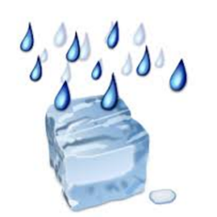 | Inaccurately sense  hot and cold | Be unaware of  temperature changes  Wear only a t-shirt  in winter

Inefficient PAIN processing

Trigger stimulus |  | What do I sense? | What might I do?
Fall over |  | Inaccurately sense  pain | Feel no pain OR  excessive pain  Be unaware of  cuts, bruises

