Why do students have difficulties with sensory processing and executive functioning?

SUMMARY:
The brain doesn’t receive required information because nerve cells are disconnected from each other.

Therefore the brain may receive information
- inconsistently
- at a different intensity
- in a way that the brain doesn’t understand

READ ON TO LEARN MORE:

Students need to apply sensory and cognitive strategies in their daily school routines. Sensation and cognition are processes in which our brain uses different pathways to obtain and use information. This information must be selected, represented, stored, retrieved and transformed so that we can feel, know and understand. How well we manage this information determines how well we can engage for learning.

The human brain contains over 10 billion neurons or nerve cells. These are the foundation building blocks for learning and development. Each neuron has several thousand connections with other neurons, creating a massive communication network:
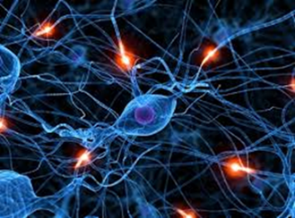

similar to a telephone switchboard, a road map or a railway interchange. Through this sophisticated network the brain communicates with itself and with other parts of the body.

When the brain is working effectively, signals flow quickly and efficiently through the communicating network. Thoughts, feelings and planned actions are easily communicated, allowing appropriate responses to be generated. For most students, the number of different signals being simultaneously processed is incalculable!

For students with executive functioning difficulties, the network can have breaks or obstacles which must be circumnavigated requiring delays or detours. If there are no time restrictions, or no stress pressures or if the task is not too complex, then the student takes the delay or detour in his stride and no resulting overt behaviour is observed.

However, difficulties are observed if the number of communications or the intensity of communications within the network escalate above the coping ability of the student who then finds it more difficult to navigate alternative routes. Above a certain threshold, signals increasingly bump into obstacles which cannot be conquered. Only some of the signals can be processed by the brain and the rest fail to reach their destination. Similar to a gridlocked freeway or jammed switchboard. Neurological processing becomes increasingly inefficient.

This overload in the brain’s network system has potential to disrupt the feedback loop between the basal ganglia, the cortex and structures such as the hypothalamus in the limbic system resulting in emotional and behavioural problems! There are no efficient pathways of communication between a student’s thinking, feelings and intentions.

